Wyandotte Breeders of America Meet Report
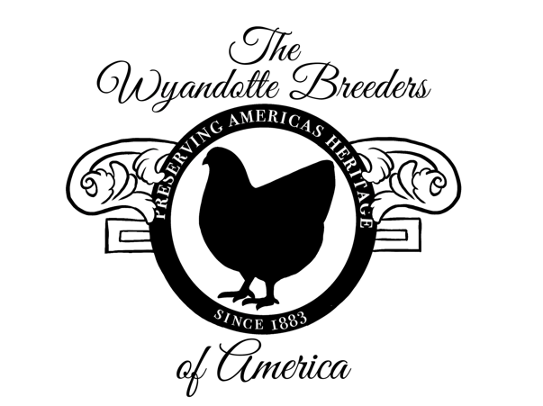

Name of Show:

Date of Show:
Person Completing Report: |  | Email:

BANTAM VARIETY | NO. IN  CLASS | BEST OF VARIETY  (enter Exhibitor’s name) | SEX  c-h-k-p
Barred
Birchen
Black
Black Breasted Red
Blue
Blue Red
Brown Red
Buff
Buff Columbian
Chocolate
Columbian
Golden Laced
Lemon Blue
Mottled
Partridge
Silver Laced
Silver Penciled
Splash
White
White Laced Red
NRV

Please see page 2 of 2

LARGE FOWL VARIETY | NO. IN  CLASS | BEST OF VARIETY  (enter Exhibitor’s name) | SEX  c-h-k-p
Black
Blue
Buff
Columbian
Golden Laced
Partridge
Silver Laced
Silver Penciled
White
NRV

 | VARIETY | SEX  c-h-k-p | EXHIBITOR
BANTAM:
Best of Breed
Reserve of Breed
Best AOV*
LARGE FOWL:
Best of Breed
Reserve of Breed
Best AOV*

Points will be awarded : 1 point for every 5 birds in competition for that variety. 20 points for Best of Breed. 10 Points for Reserve of Breed. *Best Any other Variety 5 points (@National & District Meets only)

Please complete and return, along with an Exhibitors’ List if available, within 30 days via email to:

Email: wyandottebreedersofamerica@gmail.com

For any questions, please reach out to Christina Trojak
Phone: 609-221-2846 or Email: stormyclabradors@yahoo.com

